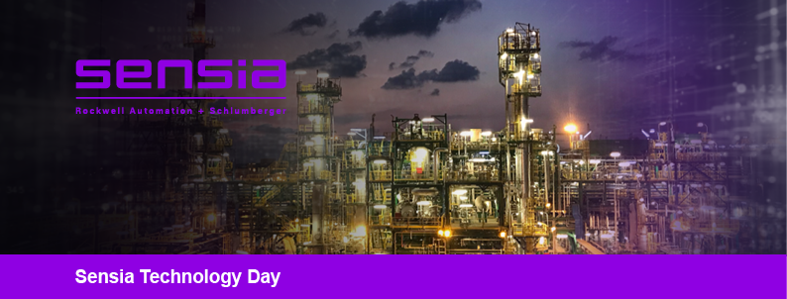
Egypt Technology Day 2023
Tuesday, 23 May 2023
Dusit Ballroom, Dusit Thani Lakeview Cairo

Purpose
Introduce Sensia’s powerful and exciting vision for the future of digital technology within the Oil and Gas Industry while building confidence and enthusiasm for Sensia as the preferred partner for digital transformation.

Overarching Message: Intelligent Action and Connection from the Edge to the Enterprise
A uniquely powerful combination of connected domain knowledge, real time automation and edge intelligence with automated insights for better decisions and execution across all cycles, at speed to continuously optimize operational and production performance, reduce costs and reduce carbon footprint.

Agenda
8:30 – 9:30 | Welcome Reception & Registration
9:30 – 9:45 | Introduction and Your Next Sustainability Step-change with Sensia  From the reservoir to the refinery, Sensia has the capability to deliver industrial-scale digitalization and seamless automation to every oil and gas company. At Sensia, we recognize the growing pressures on operators to future-proof their operations. It’s why we’re going further to make intelligent and sustainable digitalization accessible to everyone. | Safwat Hakam  Sensia

09:45 – 10:30 | Intelligent Oilfield and Real-time Production Operation Platform  Sensia explores the vision, challenges, best practices, and illustrative use cases experience at the execution of Production Operations Digitization Projects around the world. Sensia leverages the latest technology of Internet of Things to deliver a scalable and extensible Real Time Digital Production Operations Platform, allowing deployment of diagnostic applications for Artificial Lift, some of them employing Artificial Intelligence. | Thony Brito  Sensia
10:30 – 11:00 | Artificial Lift Control & Surveillance for Sucker Rod Pump & Gas Lift Solution  Whatever the size and scale of your artificial lift applications, Avalon Lift Surveillance is a powerful system to drive operational efficiency with real time data and advanced data analytics including Artificial Intelligence Response Prioritization. With the ability to generate automated workflows, your repeatable processes become more effective and secure. Put all your assets on a single platform and gain valuable performance and maintenance insights. | Thony Brito  Sensia
11:00 – 11:30 | Intelligent Integrated Petro-technical Workflows:  OFM, Avocet, PIPESIM X Geminus  Using the surrogate model, multiple sensitivity & scenarios can be run multiple time quickly with high accuracy. These will enable the operator to optimize the field production effectively, especially in an aging asset with multiple constraints & factors that needs to be addressed. | Entisar Abdurrahman Esseid  Sensia  Hatem Darwish  SLB
11:30 – 11:45 | Break
11:45 – 12:15 | Innovation Factory and AI  Digital Problem Solving and Accelerating AI adoption in Energy Sector | Dileep Divakaran  SLB

12:15 – 13:00 | Digital Metering Global View Live Uncertainty Analysis, Emissions and Flare Monitoring  Do you know how trustworthy your data is? If not, how can you ensure you are providing the correct assessment, making the right decisions, or even complying with regulations? Mismeasured data can lead to extended audits, mistrust between partners, financial penalties, and a significant amount of time reassessing data. TruST Live Uncertainty continuously analyses metering instruments and systems in real time to calculate uncertainty.  Measuring emissions is an important first step to managing them, giving you an understanding of where your main emissions are. Not meeting agreed emission limits/exceeding agreed emissions limits can have a negative impact and result in production losses. | Alex Roskoss  Sensia
13:00 – 13:30 | Flow Metering  Measurement and control of predominantly single-phase oil and gas production fluids downstream of the well head. Including processing, separation and gathering centers. Up to the point before the oil measured for fiscal accounting and transportation into pipelines and the exit of upstream into pipelines, terminals, marine transportation, loading and unloading | Fuzail Kagzi  Sensia
13:30 – 14:15 | Cybersecurity  With an ever-evolving threat landscape, O&G companies must look at security holistically, one that involves a multi-layer, risk-based approach and addresses people, process, and technologies. | Naman Taldar  Rockwell Automation
14:15 – 14:30 | Q&A
14:30 – 15:30 | Lunch

